MOST IMPORTANT

Date: 27-3-2023

NOTICE

The schedule for Semester End Examination, April 2023 has been put up on the notice boards and website of IIS (Deemed to be University), www.iisuniv.ac.in.

The examination will be conducted in two shifts i.e. Shift I (7:00 am to 9:30 am) and Shift II (10:00 am to 12:30 pm) as per the following schedule:
Shifts | Shift I | Shift II
Time | 7:00 am to 9:30 am | 10:00 am to 12:30 pm
Class | - U.G. Semester II  - U.G. Semester IV | - U.G. Semesters VI & VIII  - P.G. Semester II  - P.G. Semester IV
For all MBA Programmes EXAM TIMINGS ARE: 10:00 am – 1:00 pm

The Due Papers of Semesters II, IV, VI shall be conducted with the regular papers of the same. Students are required to report for the Due Papers accordingly.

KINDLY NOTE THAT THE BUSES WILL NOT PLY DURING THE SEMESTER END EXAMINATIONS.

For any kind of clarification and clash / discrepancy (if any), students are required to notify the same to their respective subject teachers / Dr. Nisha Yadav, Controller of Examinations / Dr. Deepa Pareek, Deputy Controller of Examinations, latest by April 7, 2023.

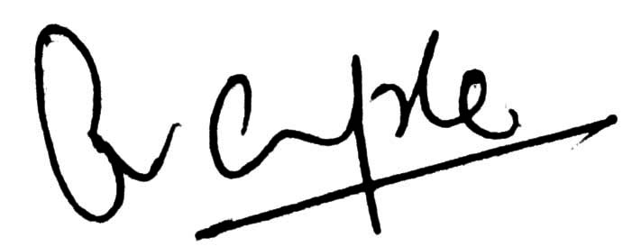
Dr. Raakhi Gupta
Registrar

